
Workflow: 3D City Data Management
Version: 1.0 beta
Date: April 5th, 2013

Introduction
This workflow explains how to perform the initial set-up of a 3D Cities database. The primary steps are:
- Setting up the database schema
- Importing essential 2D data, such as building footprints, parcels, zoning districts and street centerlines or curbs
- Importing 3D buildings
- Identifier Management
- Linking 2D and 3D data

Requirements to execute this workflow
Software:
- ArcGIS 10.1 SP1
  - 3D Analyst extension
  - Data Interoperability extension (or FME 2012)
- Microsoft Excel or OpenOffice/LibreOffice Calc for editing the configuration files

Data:
- Local Government data, CityGML or arbitrary data containing Building Footprints, Zoning Districts, Parcels and street centerlines or curbs.
- Terrain (please also refer to the documentation for the 3D City Editing App for information on how to create a digital elevation model)
- 3D Building models

Part 1: Setup a database schema
The pivot point of your 3D city is the 3D city database. This database uses the 3D City Information Model (3DCIM). You can either use parts of it or all its aspects. It works with any file format or database type; however, the tools presented in this workflow have been developed with the capabilities of File Geodatabases in mind.
Setting up the data model can be done using one of these two methods:
- Import the XML Workspace schema-only document. You will find the schema-only XML workspace file as part of this template in InformationModel/ 3D Cities-1.0-schema.xml. You will find more information on how to import this file here.
- Use the 3DCIM Schema Tools Python Toolbox. This method is recommended if you need more control, e.g. you only want to create the domains or you directly want to set a new spatial reference system. This method is described below.
The 3DCIM Toolboxes, including the Schema Tools, are available in the Catalog view when you open the 3dCityMaintenance.mxd App in ArcMap.
If you want to use the tools in ArcCatalog, add a Folder Link to the App Folder to see and execute the tools. If ArcCatalog doesn’t start up after linking in the toolboxes, delete the file called ArcToolbox.dat in the ArcToolbox folder.
To use the Schema Tools, proceed as follows:
- Open ArcCatalog;
- Create a new File Geodatabase. You can give it any name, no specific one is required.
- Open the 3DCIM Schema Tools Python Toolbox;
- Double-click the 3DCIM Database Schema Generator Tool, and the following dialog will be displayed:
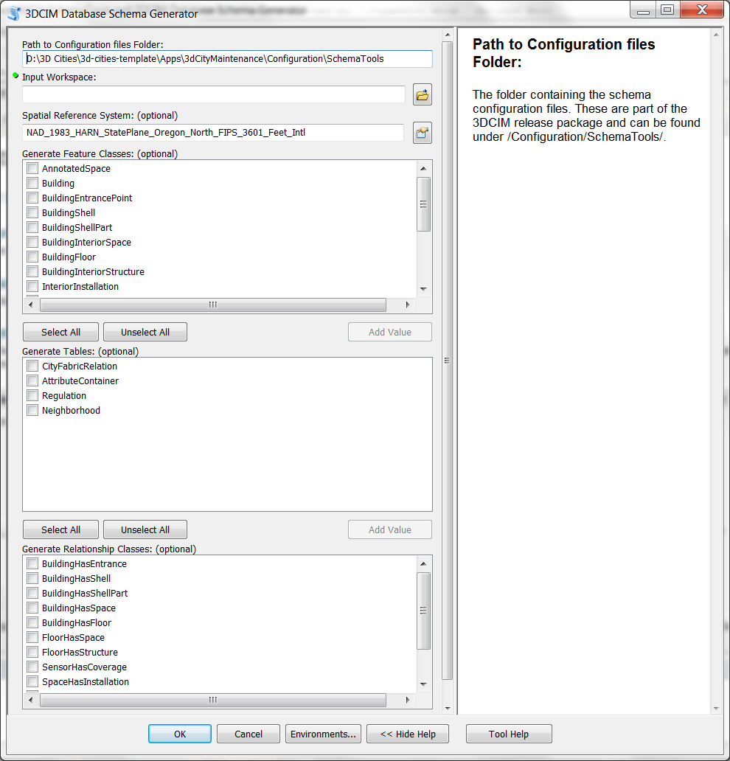
- Pick the correct “Path to Configuration Files Folder” (last parameter on the page). These configuration files come with the download package and are located in the folder Apps/3dCityMaintenance/Configuration/SchemaTools;
- Chose the File GDB you created before in the “Input Workspace” parameter;
- Optionally, chose the Spatial Reference System you want to use;
- Pick the Feature Classes, Object Tables and Relationship classes you want to create;
- Press OK and let the tool run. Setting up the domains typically takes up to a minute, all other parts run through very quickly.
In the next steps, you can use the newly created and configured database as the target workspace for all the import processes.

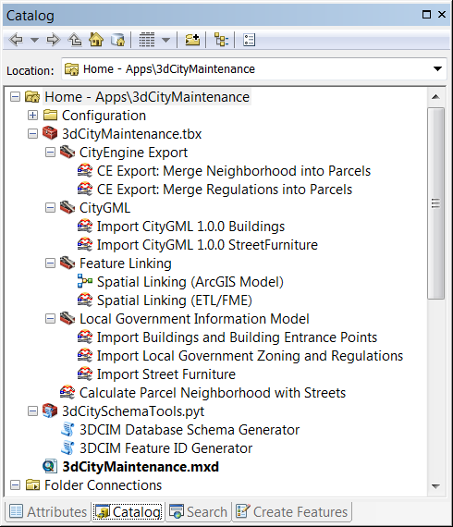
Part 2: Import Data
There are multiple ways of importing data into the 3DCIM with different levels of support. You can either import data from the Local Government Information model, from CityGML 1.0 or from a custom file or database schema. For the first two options, the ETL toolbox “3D City Maintenance” offers ready-made tools that allow you to transform your data using minimal configuration effort. For the third option, you’ll find an example in the “3DCIM Portland Examples Toolbox”, but you will have to adjust the ETL tool to match your source data.

Importing from the Local Government Information Model
At the current stage, you can import parts of the built environment and parts of the legal environment of the 3DCIM from an existing Local Government for ArcGIS 10.1 database. If you do not have an existing database, you can download the example database for the city of Naperville, Illinois from the ArcGIS resource center.
First, import Buildings and Building Entrance Points (SiteAdressPoints in the Local Government geodatabase).
- Open the “3D City Maintenance” toolbox, open the set called “Local Government Information Model”, and double-click on the “Import Buildings and Building Entrance Points” tool. This dialog opens:
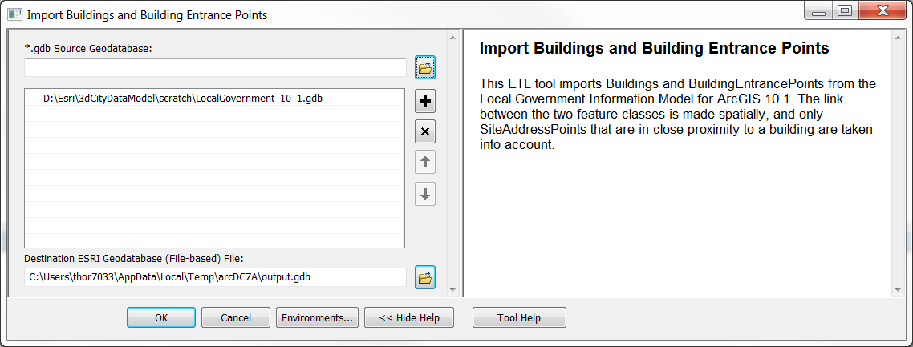
- Pick the correct Source File geodatabase, as well as the Destination File Geodatabase that you created in Part 1. Then, press “OK” and let the tool run.
Then, if available, continue to import Street Furniture features, for which there is also a specific tool.
- Open the “3D City Maintenance” toolbox, open the set called “Local Government Information Model”, and double-click on the “Import Street Furniture” tool. A similar dialogue to the one shown above opens.
- Pick the correct Source File geodatabase, as well as the Destination File Geodatabase that you created in Part 1. Then, press “OK” and let the tool run.
A third tool allows you to import ZoningDistricts and ZoningRegulations from the Local Government Information Model:
- Open the “3D City Maintenance” toolbox, open the set called “Local Government Information Model”, and double-click on the “Import Local Government Zoning and Regulations” tool. This dialog opens:
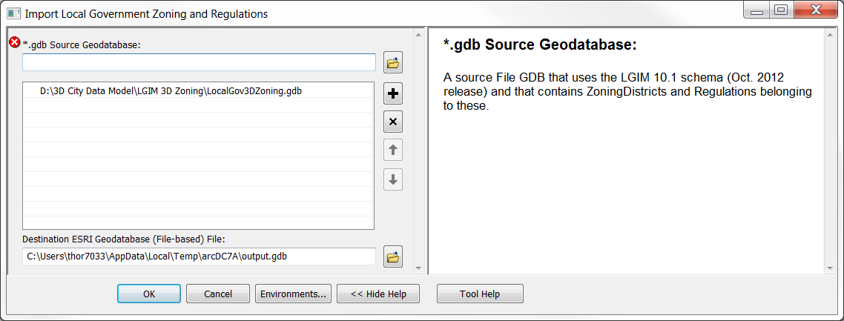
- Pick the correct Source File geodatabase, as well as the Destination File Geodatabase that you created in Part 1. Then, press “OK” and let the tool run.
For all of the tools, if there are derivations in the source database (e.g. because an older version of the Local Government Information Model was used or because custom domains have been defined), problems might occur, such as a reclassification of an attribute not working correctly. You should thus verify the results of the data import, e.g. by assessing the data in ArcMap.

Importing from CityGML 1.0
CityGML files can contain several feature types that are relevant to building up a 3DCIM database. Using the current toolset, you can import Buildings, BuildingShells, StreetFurniture and Trees. If you do not have CityGML 1.0 datasets but would like to test this workflow, you can download official test datasets from http://www.citygml.org.
First, import Buildings and Building Shells.
- Open the “3D City Maintenance” toolbox, open the set called “CityGML”, and double-click on the “Import CityGML 1.0.0 Buildings” tool. The following dialogue opens:
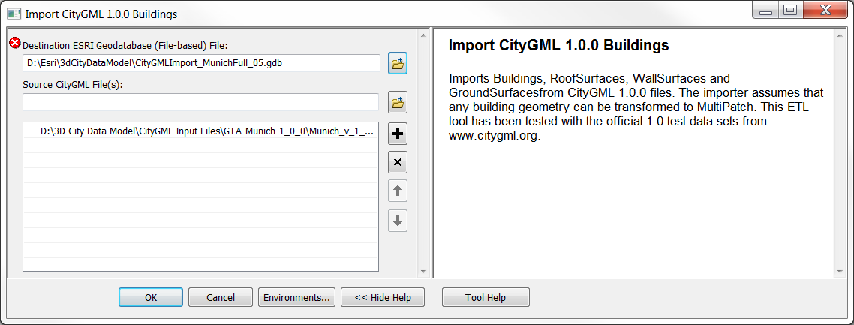
- Pick any number of source CityGML 1.0.0 files, as well as the Destination File Geodatabase that you created in Part 1. Then, press “OK” and let the tool run.
If your CityGML dataset contains street furniture, use the next tool to import that as well.
- Open the “3D City Maintenance” toolbox, open the set called “CityGML”, and double-click on the “Import CityGML 1.0.0 Street Furniture” tool. A similar dialogue to the one shown above opens.
- Pick any number of source CityGML 1.0.0 files, as well as the Destination File Geodatabase that you created in Part 1. Then, press “OK” and let the tool run.
Even though CityGML is a standard, it is well-known that there are many interpretations around the standard, leading to limited interoperability. The tools described above have been tested with the official test data sets. If your datasets include derivations, problems might occur, such as a reclassification of an attribute not working correctly. You should thus verify the results of the data import, e.g. by assessing the data in ArcMap.

Importing from a custom database or file schema
Many users will store their 3D city relevant data in custom database schemas and might not be able to transform their data to CityGML. In this case, a custom ETL tool will be needed. The 3DCIM package comes with example ETL tools based on the Portland, Oregon, case. You will find these tools in the “3DCIM Portland Examples Toolbox”. This section walks you through their use and provides an introduction on how to modify them.
First, import the buildings.
- Open the “3DCIM Portland Examples Toolbox” toolbox, and double-click on the “Import Building Footprints”. The following dialogue opens:
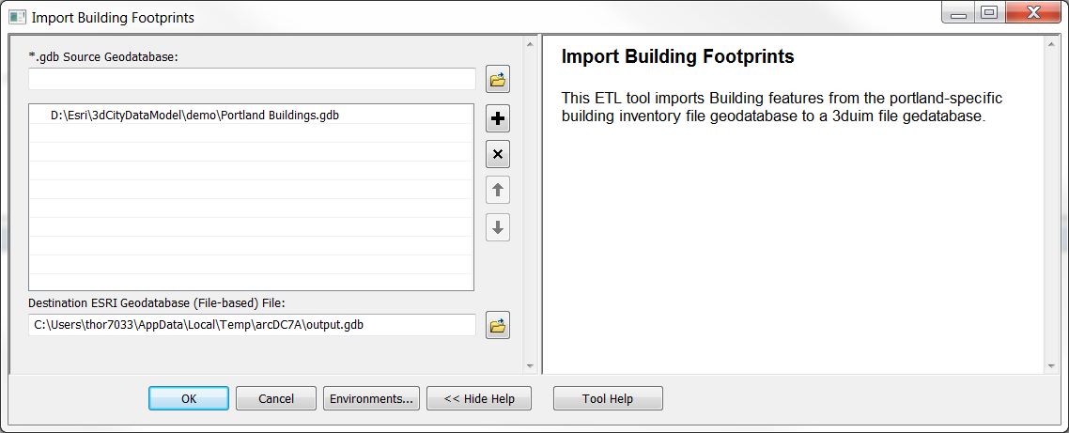
- Select the Portland Building shapefile from \Samples\Portland\PortlandExample\Buildings.shp as source, and pick a 3DCIM file geodatabase as target. Then, press “OK” and let the tool run.
The other tools in this toolbox use the same pattern to be run. If you need to import from a different schema, right-click on the tool and pick “Edit…”. The FME Workbench will start up, allowing you to see the model behind it and be able to edit it. To get detailed information on how to use the FME workbench, please refer to the FMEpedia.
The principal workflow for adjusting an existing FME workspace/Data Interoperability ETL Tool to your source schema is as follows:
- If you are importing from a different format than File GDB (e.g. Shapefiles), add a new Reader:
  - Go to Readers -> Add Reader, and pick the required format by entering the file extension, such as “shp”.
  - Optionally, pick the concrete data set that you want to transform. Leave the option “Individual Feature Types” active. After pressing “OK”, FME will read the file and add new reader feature types to the workspace. You can now connect these new feature types and delete those of the old reader.
- If you are importing from a File GDB, you will need to adjust the reader’s feature types.
  - Go to Readers -> Import Feature Types, and first pick the file GDB reader (if there is more than one reader in the workspace.
  - Then, in the field “Source Dataset”, chose your source File GDB and press OK.
  - Select the feature types you want to import and add them.
- Next, connect the new feature types to the existing process, and remove the old ones. You will now need to perform modifications to the workspace, e.g. changing parameter names in Transformers or changing the values in AttributeValueMappers. Furthermore, you will need to check the connection between the last transformer and the writer feature type. Make sure than any connection to an attribute of the writer feature type that you can make is actually there. This image shows a simple data import workspace:
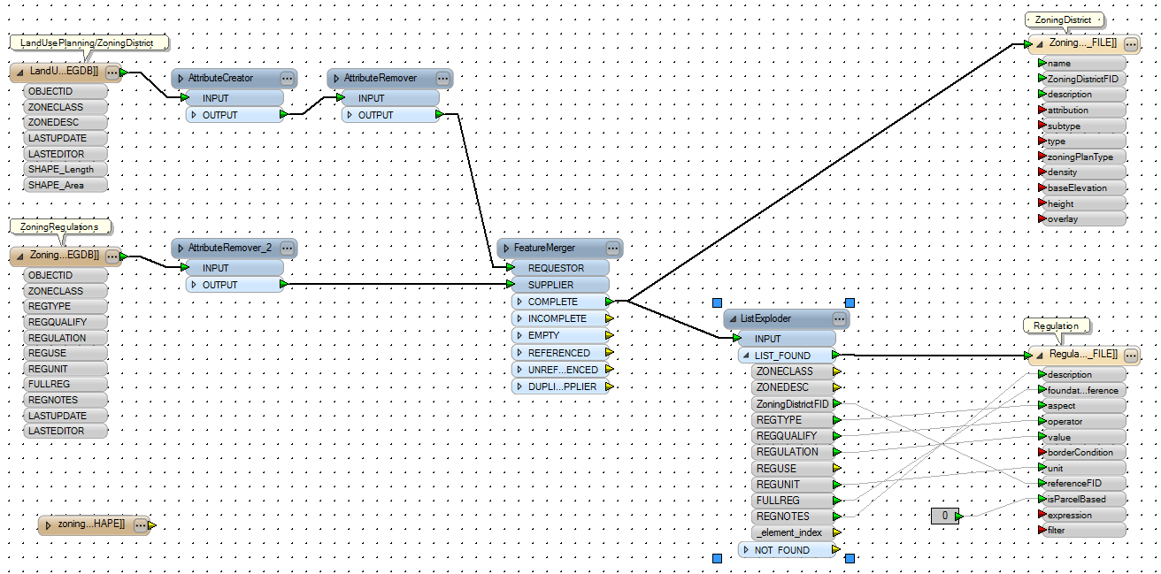
In any case, you should always write to file geodatabases that you have created using one of the two methods described in Part 1 of this workflow. Otherwise, the domains and related relationship classes will be missing.

Importing BuildingShells from files
Quite often, 3D building models are available in separate files from the rest of the 3D city data. Files such as Collada/KML, Open Flight, 3ds, VRML or OBJ, contain the 3D geometries and the textures (or links to the textures). These can be imported using the existing tools from the 3D analyst extension. In this section, a brief walkthrough of their usage is given.
- In any of the ArcGIS Desktop applications, go to “System Toolboxes”, open the “3D Analyst Toolbox”, and chose “Conversion-> From File -> Import 3D Files”. The GP tool has these parameters:
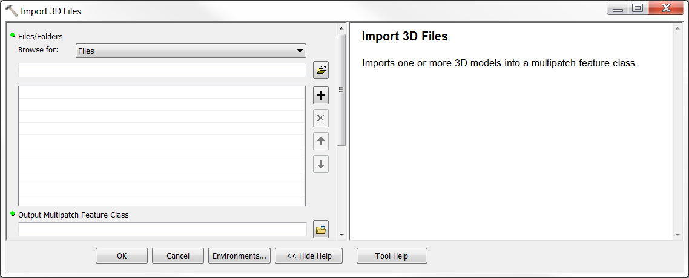
- Pick the files or folders you want to import, and then pick the Output Multipatch Feature Class. This output feature class should be written to a scratch File Geodatabase. Press “OK” and let the tool run.
- In the next step, the imported multipatch features need to be converted to 3DCIM BuildingShell and/or BuildingShellPart features and stored in your 3DCIM File Geodatabase. You can do this as follows:
  - In the Catalog Tree, expand your 3DCIM File Geodatabase, and right-click on BuildingShell. Pick “Load -> Load Data…”.
  - Select the File GDB to which you imported the Multipatch feature in steps 1 and 2, and select the feature class you created in step 2.
  - Confirm the selection of the source and target feature classes, and go on to the next dialogue, which allows you map source and target attributes on a 1:1 basis. Usually, there won’t be many attributes attached to the source Multipatch buildings. The mapper looks like this:
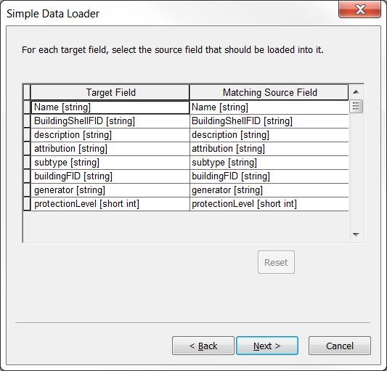
  - In the next step, chose whether you want to load all data or just data that conforms to a given query. Finally, confirm the selected options and let data be loaded.
You can get more information on the simple data loader used in step 3 online. Alternatively, if you want to add more information to the BuildingShell features as they are created, you should use an ETL tool.

Part 3: Identifier management
You have now filled parts of the 3DCIM database with content. At this stage, it is time to make a decision how feature identifiers should be handled in your 3DCIM. File Geodatabases have a field called OBJECTID that serves as an internal identifier that is unique within a single feature class. However, if you move a feature from one GDB to another, there is no guarantee that it will retain the same OBJECTID. For this reason and others, it is common to use a second identifier also called the “business identifier” for features that is controlled by the application and usually has specific semantic elements. This section explains how to use such identifiers with the 3DCIM.
Our recommend approach – which is implemented throughout the example tools – is to use Partially Qualified Names, with Hi-Lo Sequencing used to generate the local part if no suitable business identifier was available from the source data. Such an identifier can look like this (the Type portion is optional and can be used with Subtypes):
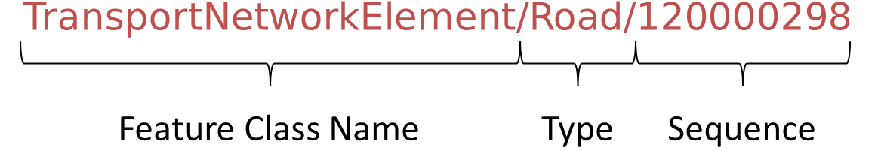

The 3DCIM comes with a tool that will generate such IDs for all features in the geodatabase for you, if it doesn’t encounter filled FID fields. To use this tool, proceed as follows:
- Open the “3DCIM Schema Tools” python toolbox and double-click on the “3DCIM Feature ID Generator” tool. This dialogue is displayed: 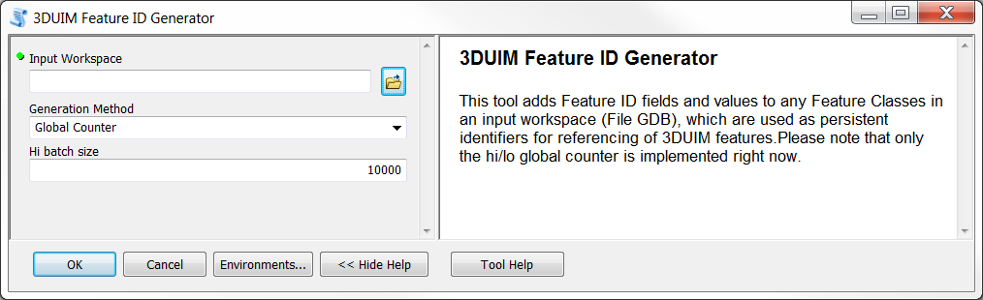
- Select your 3DCIM database as Input workspace, chose your ID generation method (currently, only the recommend hi/lo counter is implemented) and pick a Hi batch size (the number of features that a single process gives IDs to before syncing with the database again) if you know that the default value wouldn’t work for you. Press OK and let the tool run.
For a more detailed explanation of Identification strategies, please refer to Appendix I.

Part 4: (Spatial) Linking
The final step in setting up a 3DCIM database is to perform linking of the imported feature classes. The 3DCIM makes use of several Relationship classes to connect features from different classes to each other. An example is the relation between Building and BuildingShell. To add relationship data to your 3DCIM database, there are two ways to proceed:
- Use a key property that both classes to be related share. This is computationally relatively easy and thus fast. It should be performed during import (the models included with the 3DCIM package perform it where possible and can be adjusted to fit your needs).
- Use the spatial location that both classes have. This is only suggested if there is no other way of relating the features, as this method is more expensive and can also introduce errors.
The 3D City Maintenance toolbox contains example tools that can be used to perform spatial linking. By default, they work on Buildings and BuildingShells and update an existing database instead of adding new feature classes. If you need to link other feature classes (e.g. InteriorSpaces to Buildings), modify the models by adding Reader Feature Types in the FME Workbench. To use ETL tools, continue as follows:
- Go to the “3D City Maintenance” toolbox, open the toolset labeled “Feature Linking”, and chose one of the two available tools. If you need high precision spatial linking, use the ETL tool called “Spatial Linking (ETL/FME)”. This tool uses straight skeletons to compute a very reliable spatial fit. However, due to a known bug in FME 2012/Data Interoperability 10.1, it will not work with textured multipatch datasets larger than a few hundred features. If you need to match such datasets, use the second tool called “Spatial Linking (ArcGIS Model)”. It is slightly less reliable, but works with textured multipatch datasets of any size.
- If you are running the ETL/FME tool, you’ll see this dialogue:
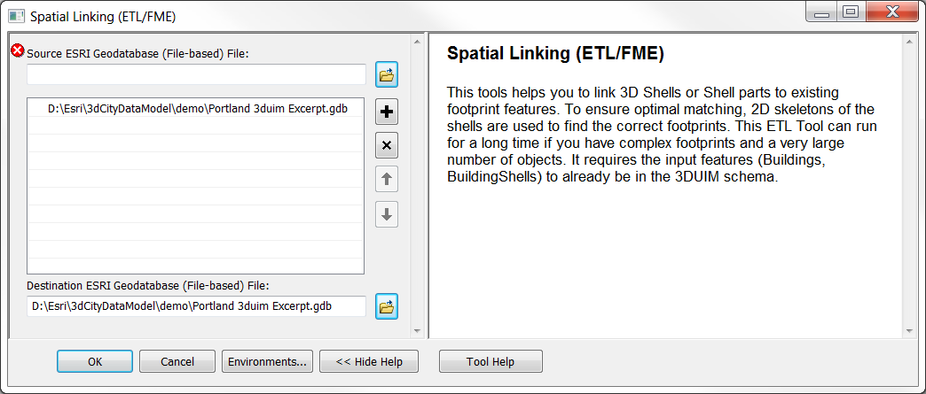
  - Chose the source ESRI geodatabase. The tool works in update mode by default, so that the massive multipatch features don’t have to be rewritten, so enter the same ESRI geodatabase as the destination. Click “OK” and let the tool run. If it takes very long or abruptly ends, you’ll have to use the ArcGIS Model.
- The ArcGIS Model expects to be run from within ArcGIS (ArcMap, ArcScene or ArcGlobe), with the 3DCIM feature classes Building and BuildingShell added to the document. In this situation you can directly run the tool without entering any additional parameters. If you edit the tool, you’ll see this:
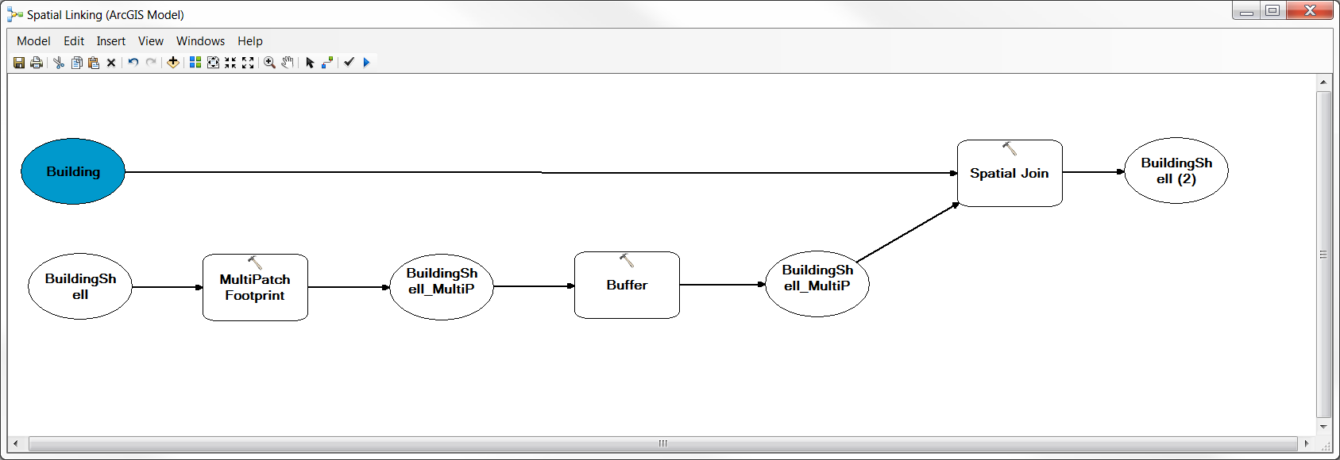
That’s it, you have set up the first parts of your 3D City Information Model!
Let’s move on to add a complete 3D City Zoning environment in Workflow 2: Importing and Changing Regulations.

Appendix I: Spatial Feature Identification Strategies

Sequences: 23140
Simple short or long integer sequences are the most common form of identifiers. They are simple to generate, simple to index, and simple to use, but are also completely opaque and devoid of any meaning. This makes them ideal candidates for system-internal identification. Sequences are typically managed by the database system.

Hi-Lo Sequences: 135002349
Hi-Lo-Sequences have the same advantages and disadvantages as normal sequences, but one additional property: The identifier generation can in part be handled by the client, e.g. a GP tool or ETL script loading data. The client receives the range of numbers it can assign to features, e.g. 0 … 9999 (the “Low” component), and a fixed starting number, such as 135,000,000. This is especially important if multiple client applications access the same database at the same time, to avoid any collisions.

Natural Keys, Business Identifiers: 1530 SE Hawthorne Blvd
Natural keys are readable and understandable identifiers, such as addresses. Their big advantage is their transparency and the direct meaning they carry. The main difficulty with these is that quite often, there is no natural key that is truly unique for all features, so that compound keys are used.

UUIDs: 550e8400-e29b-11d4-a716-446655440000
The intent of Universally Unique Identifiers (UUIDs) is to enable distributed systems to uniquely identify information without significant central coordination. UUIDs embody the opposite concept than natural keys: They are completely opaque and don’t carry obvious semantics. However, they can be considered "practically unique": Since the identifiers have a finite size it is possible for two differing items to share the same identifier. However, anyone can create a UUID and use it to identify something with reasonable confidence that the same identifier will never be unintentionally created by anyone to identify something else. Information labeled with UUIDs can therefore be later combined into a single database without needing to resolve identifier (ID) conflicts.

(Fully) Qualified Name: http://3dcities.esri.com/featureService/built/Building/2394187091/4
Qualified names consist of a namespace part, a localname part, and optionally version information. The localname part can be created using any of the other methods. Fully qualified names built on a URI/URL namespace scheme are guaranteed to be universally unique, but as opposed to UUIDs, they are transparent and provide a lot of information to the reader, including the responsible authority, the dataset that it belongs to, the feature class name, its local identifier and the version of that feature (here: 4). Another big advantage is that they are either directly resolvable or at least registry resolvable, i.e. somebody can directly use this identifier as a (HTTP) link in any application. This is especially handy in web applications.
Their main disadvantage is the size of identifier, especially if it is a fully qualified name as often used to reference in XML documents. This makes them harder to handle and index. This disadvantage can be offset to some degree by using partially qualified names such as “Building/2394187091”.

Template: 3D City Data Management
Version: 1.0 beta
Date: April 5, 2013

Release Notes
The November 30, 2012 release is the first release of the 3D Data Management workflow for ArcGIS 10.1.

New Functionality

N/A

Resolved Problems

N/A

Known Issues

N/A

this bug is fixed in FME 2013/Data Interoperability 10.2.

